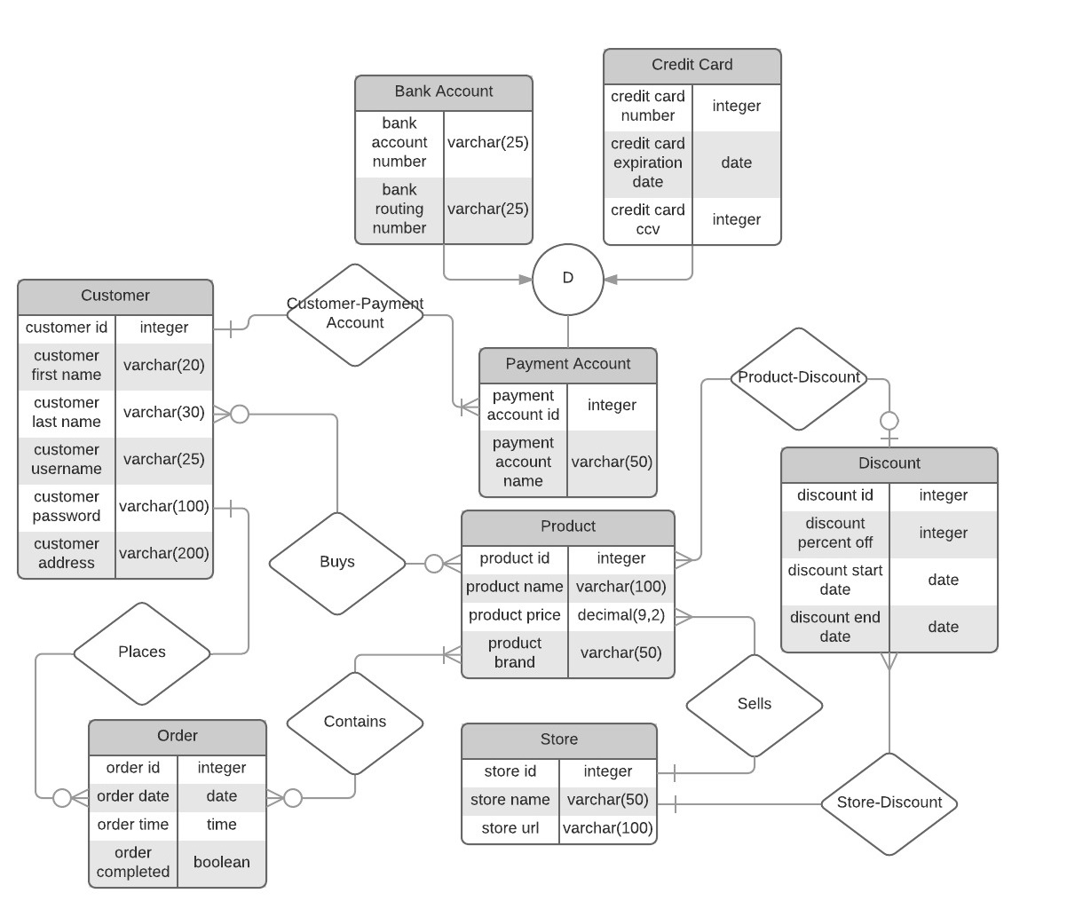

Customer(customer_ID, customer_first_name, customer_last_name, customer_user_name, customer_password, customer_address, Payment.account_ID)

Order(order_ID, order_date, order_time, order_completed, Customer.customer_ID, Product.product_ID)

Payment(account_ID, account_Name, Customer.customer_ID, Bank.bank_account_number, Card_card_Number)

Bank(bank_account_number, bank_routing_number, payment.account_ID)

Card(card_number, card_expiration_date, card_ccv, payment.account_ID)

Product(product_ID, product_Name, product_price, product_brand, Store.store_ID, Discounts.discount_ID)

Store(store_ID, store_name, store_URL)

Discounts(discount_ID, discount_percent_off, discount_start_date, discount_end_date, Product.product_ID, Store.store_ID)

Constraints:

Not Null: customer_ID, order_ID, account_ID, product_ID, store_ID, discount_ID, account_Name, order_completed, store_name, discount_percent_off, discount_start_date, discount_end_date, customer_user_name, customer_password, customer_address

Unique: customer_ID, order_ID, product_ID, store_ID, discount_ID, store_URL, payment_account_id, bank_account_number, card_number

Functional Dependencies:

**Customer table:**

F= {customer_ID -> customer_first_name, customer_last_name, customer_address, customer_user_name, customer_password, payment.account_ID

customer_user_name -> customer_first_name, customer_last_name, customer_ID

}

**Order Table:**

F= {Order_ID -> order_date, order_time, order_completed, Customer.customer_ID, Product.product_ID}

**Payment Table:**

F= {account_ID -> account_Name, Customer.customer_ID, Bank.bank_account_number, Card.card_Number}

**Bank account Table:**

F= {bank_account_number -> bank_routing_number, payment.account_ID)

**Card Table:**

F= {card_number -> card_expiration_date, card_ccv, payment.account_ID}

**Product Table:**

F= {product_ID -> product_name, product_price, product_brand, Store.store_ID, Discounts.discount_ID}

**Store Table:**

F= {store_ID -> store_name, store_api,

store_URL -> store_ID, store_name}

**Discounts Table:**

F= {discount_ID -> discount_percent_off, discount_start_date, discount_end_date, Product.product_ID, Store.store_ID}

Decomposition is not necessary because all relations are in BCNF and 4th Normal Form.

Customer Table:

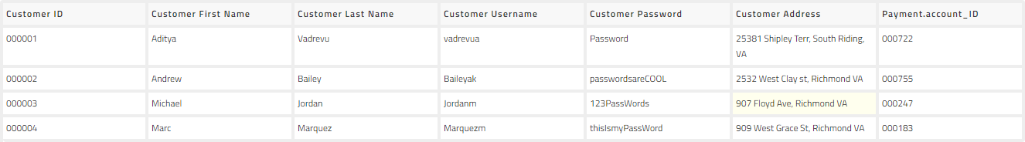

Order Table:

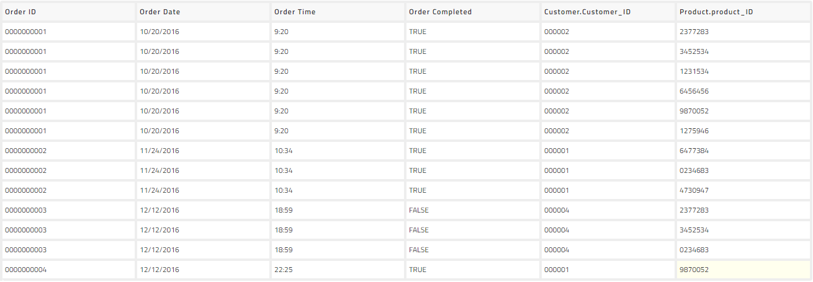

Payment Account Table:

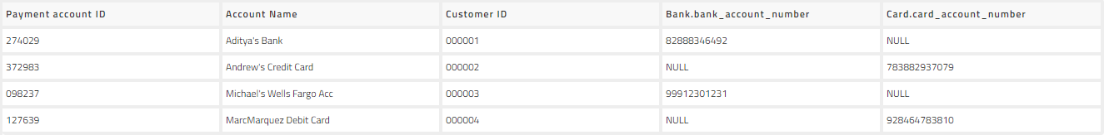

Bank Account Table:



Card Account Table:

Discount Table:

Product Table: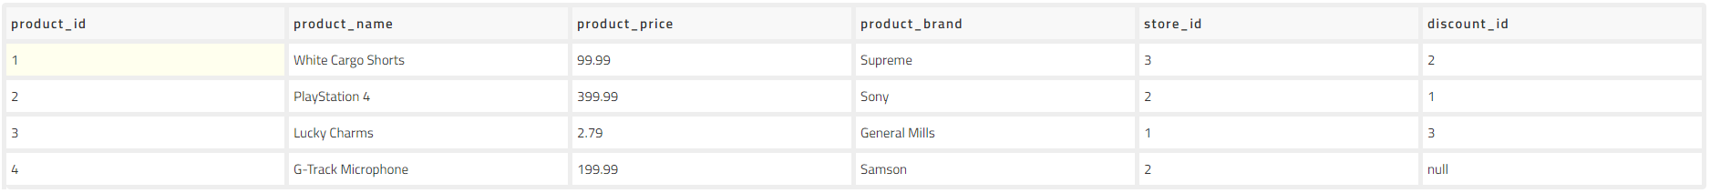

Store Table:

